**National University of Computer and Emerging Sciences**



Laboratory Manual

for

Data Structures Lab

|  |  |
| --- | --- |
| Course Instructor | Dr. Zareen Alamgir |
| Lab Instructor(s) | Fariha Maqbool  Humna Shabir |
| Section | BCS-3F |
| Semester | Fall 2022 |

**Department of Computer Science**

FAST-NU, Lahore, Pakistan

**Objectives:**

In this lab, students will practice:

1. Circular Linked List
2. Iterators

**Question 1**

Create a circular link list template class with an inner iterator class. You are required to compute the sum of all nodes in the list except the current node and delete the current node if the sum is even. Keep on repeating this until we have checked all the nodes remaining in the list. Create suitable functions to complete this task and an appropriate driver function to check the functionality.

**For example:**

We have the following link list

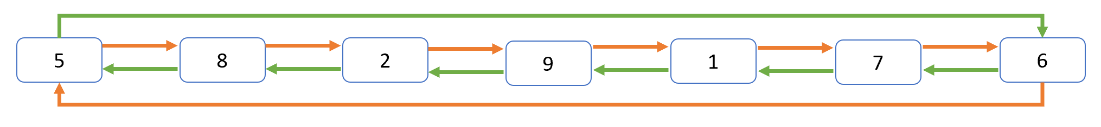

**Step 1:**

Current Node = 5

Sum= 8+2+9+1+7+6 = 33 (Odd)

Iterate to next node

**Step 2:**

Current Node = 8

Sum= 2+9+1+7+6+5 = 30 (Even)

Delete node 8

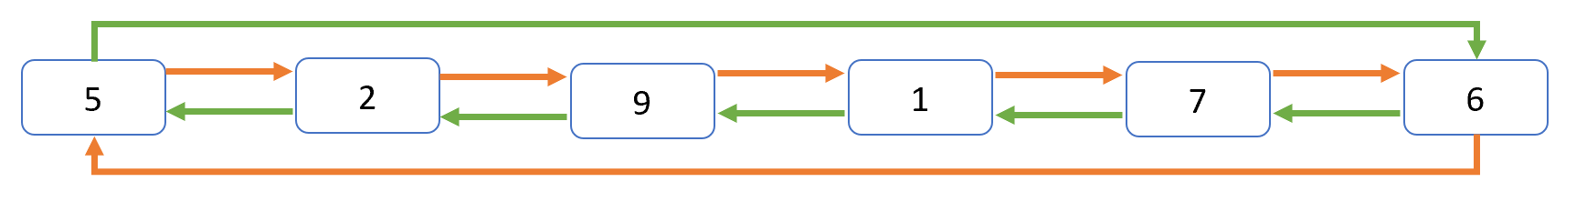

**Step 3:**

Current Node = 2

Sum= 9+1+7+6+5+8 = 28 (Even)

Delete node 2

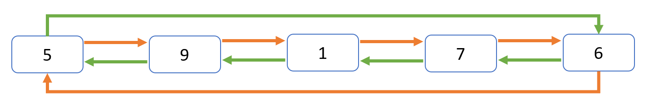

**Step 4:**

Current Node = 9

Sum= 1+7+6+5 = 19 (Odd)

Iterate to next node

**Step 5:**

Current Node = 1

Sum= 7+6+5+9 = 27 (Odd)

Iterate to next node

**Step 6:**

Current Node = 7

Sum= 6+5+9+1 = 21 (Odd)

Iterate to next node

**Step 7:**

Current Node = 6

Sum= 5+9+1+7 = 22 (Odd)

Delete node 6

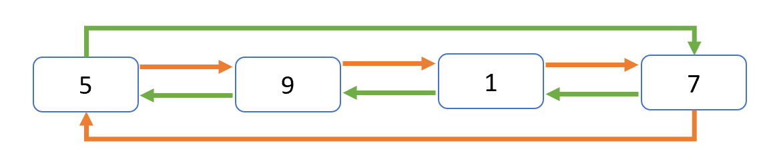

**Question 2:**

You are the owner of a unique hotel that has its rooms arranged in a circle. There are several types of rooms in the order and each have different capacity of guests it can accommodate. Each node of a link list represent a room. You are required to make a single circular link list that contains the following data members:

**Type:** room type (single, double, triplet, quad, family, suite)

**Capacity:** no. of guests a room can accommodate (1, 2, 3,4, 6, 10)

**Guests:** no. of guests currently living in the room

**Filled:** if a room is filled or not (Yes/No)

You are assigned the task of the hotel receptionist and are suppose to allocate rooms to the guests according to their requirements. Using iterator class as the inner class of circular list you are to traverse the hotel rooms for perfect match. If a room is filled then you are required to skip it during every traversal.

**Starting with the list given below:**

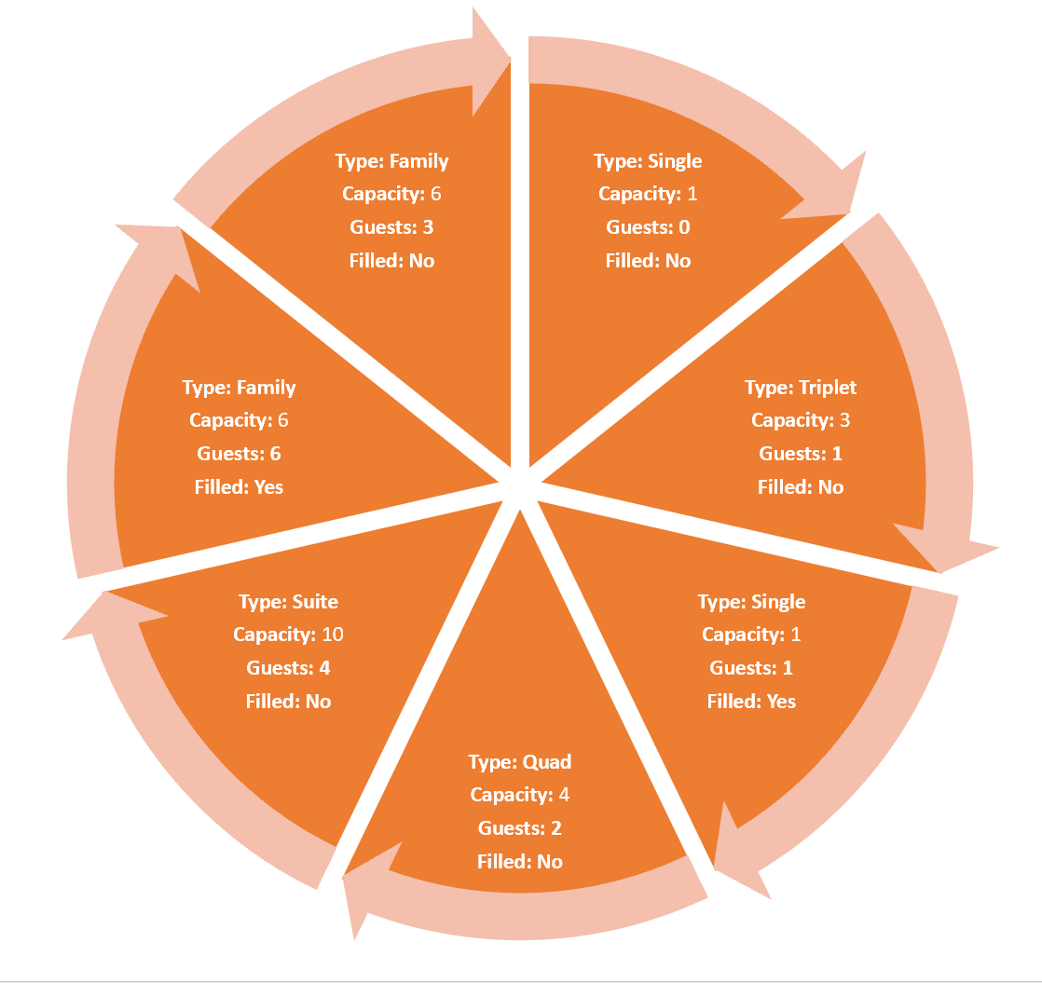

**Accommodate the following guest:**

2 guests for Quad

2 guests for family

1 guest for triplet

5 guests for suite

1 guest for single

**Note: After assigning rooms to guests don’t forget to change no of the guests in the rooms and its filled status.**